In this lab, you will experience what its like to be a cloud architect working for an IT company. Recently, the company has seen cases of malfunctioning of EC2 instances and databases leading to service outage. You have been tasked with designing and implementing a resilient system that supports auto-recovery of EC2 instances and EBS from failures. The system must also support Multi-AZ deployment of RDS database instances for high availability and failover support. You will use CloudWatch and SNS for monitoring the EC2 instances as well as the RDS instances.

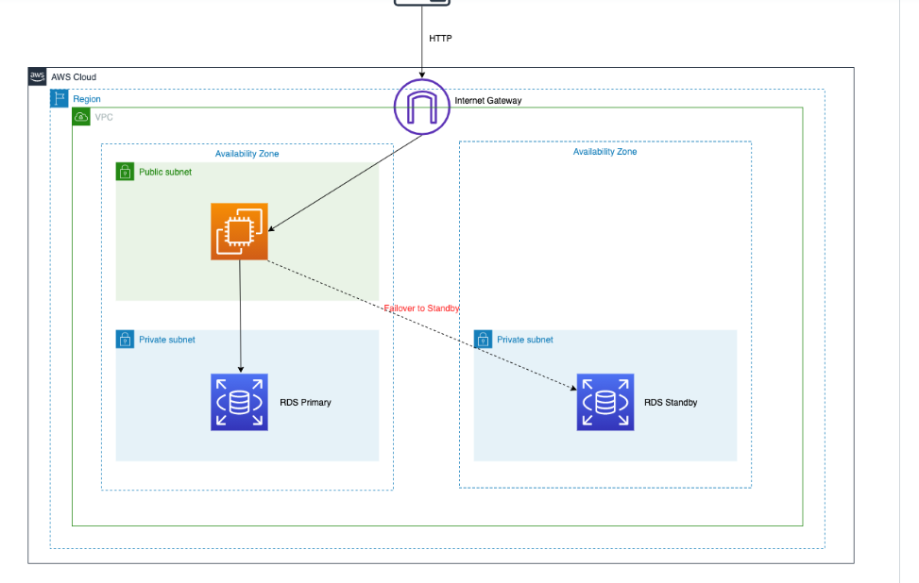

Create Public Subnet to Launch EC2 instance:

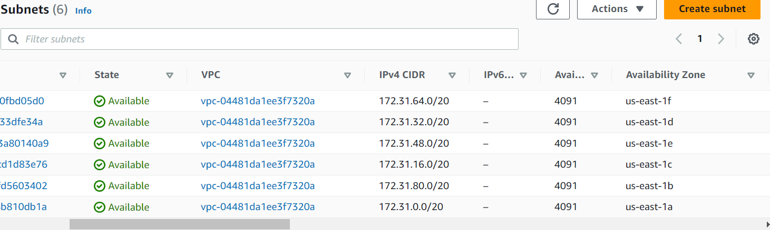

New Subnet:

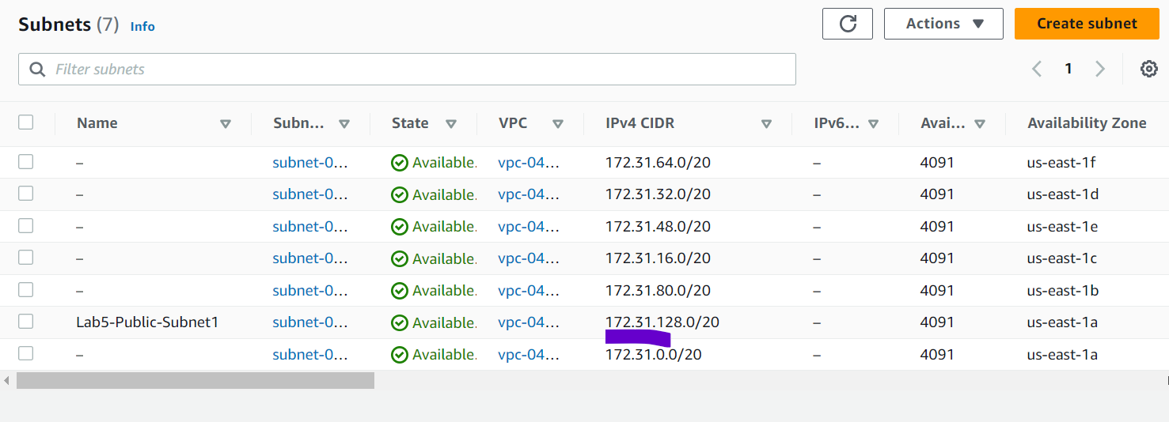

role for EC2 instance to invoke a CloudWatch alarm.

